Table of Contents

**Lab Prerequisites** 2

**Goals for this Lab** 2

*Scenario : Create a Facebook account and setup the page in developer mode* 2

*Task 1 : Setting up the first Facebook page* 2

*Task 2 : Setting up connection from Facebook Messenger app to Dynamics 365 Omnichannel* 6

FACEBOOK DEVELOPER SETUP

## Lab Prerequisites

1. Office 365 Omnichannel installed
2. Facebook Account

## Goals for this Lab

After this lesson, you will be able to : Create a Facebook organization page to communicate with public community with Dynamics 365 Omnichannel.

## Scenario : Create a Facebook account and setup the page in developer mode

### Task 1 : Setting up the first Facebook page

1. Go to [www.facebook.com](http://www.facebook.com) and create a new account. Continue follow the steps in Facebook, until you get into the fresh Facebook page.  
   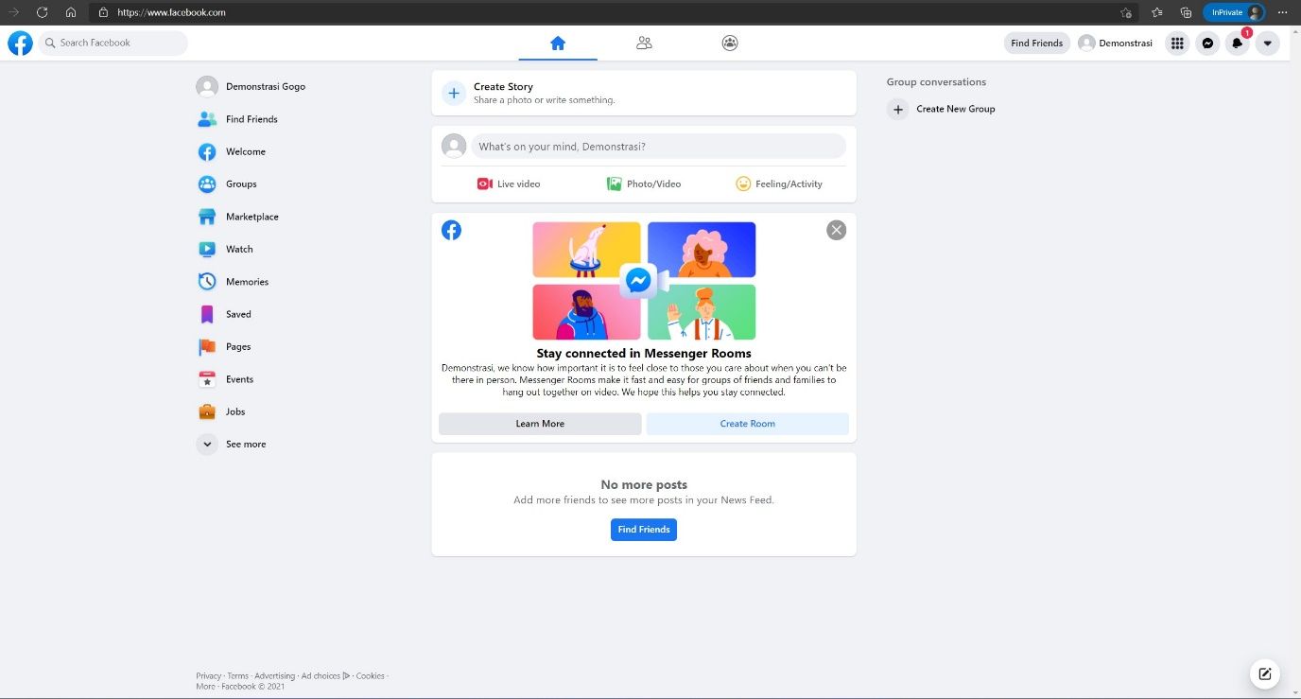
2. Open <https://developers.facebook.com> and click ‘Get Started’  
     
   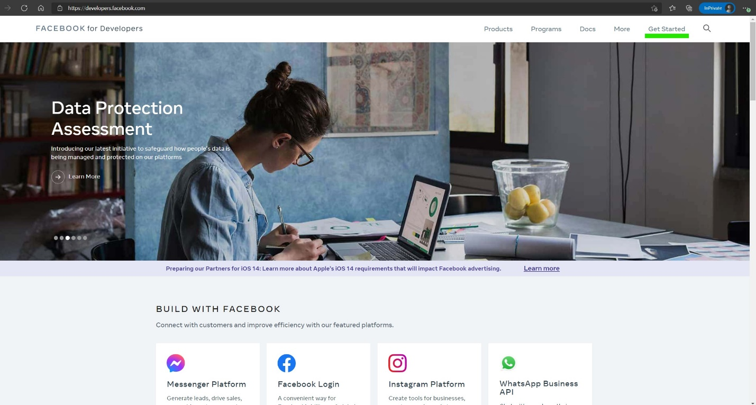
3. Follow the developer registration process and verify your account  
     
   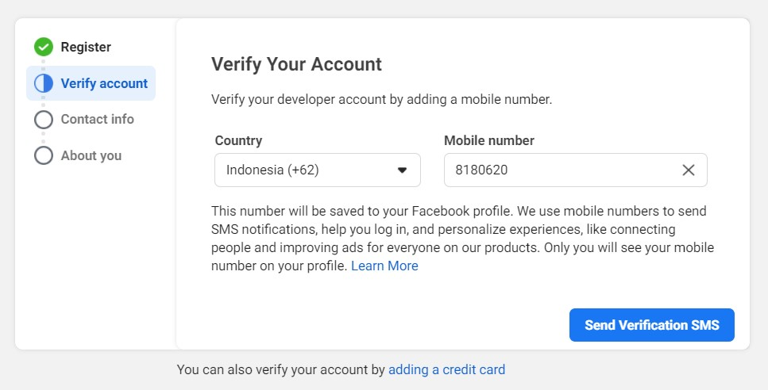  
     
   Graphical user interface

   Description automatically generated
4. After finish the registration process, click ‘Create App’  
     
   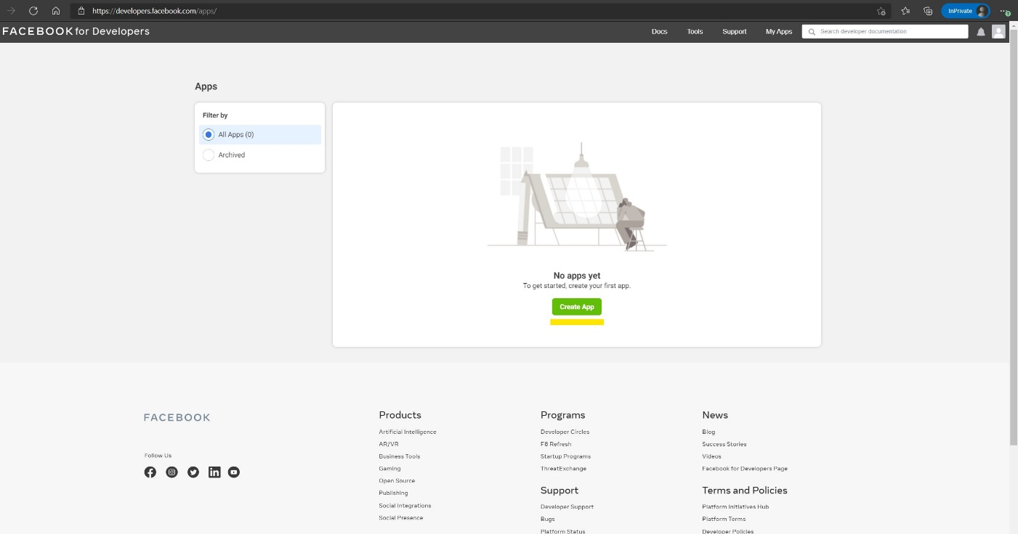
5. Select the App Type to ‘Business’ and fill out the details and click ‘Next’

|  |  |
| --- | --- |
|  |  |

1. After you created the App, then you should arrive at this screen. Click ‘Messenger’.  
     
   Graphical user interface, application, website

   Description automatically generated
2. Click ‘Create a new page’  
     
   Graphical user interface, text, application, email

   Description automatically generated

1. Finally, finish setting up your page as you like. You can click ‘Save’ afterward.  
     
   Graphical user interface, website

   Description automatically generated

### Task 2 : Setting up connection from Facebook Messenger app to Dynamics 365 Omnichannel

1. Go to the landing page of developers.facebook.com. Navigate to Messenger 🡪 Settings. Click ‘Add or Remove Pages’.  
     
   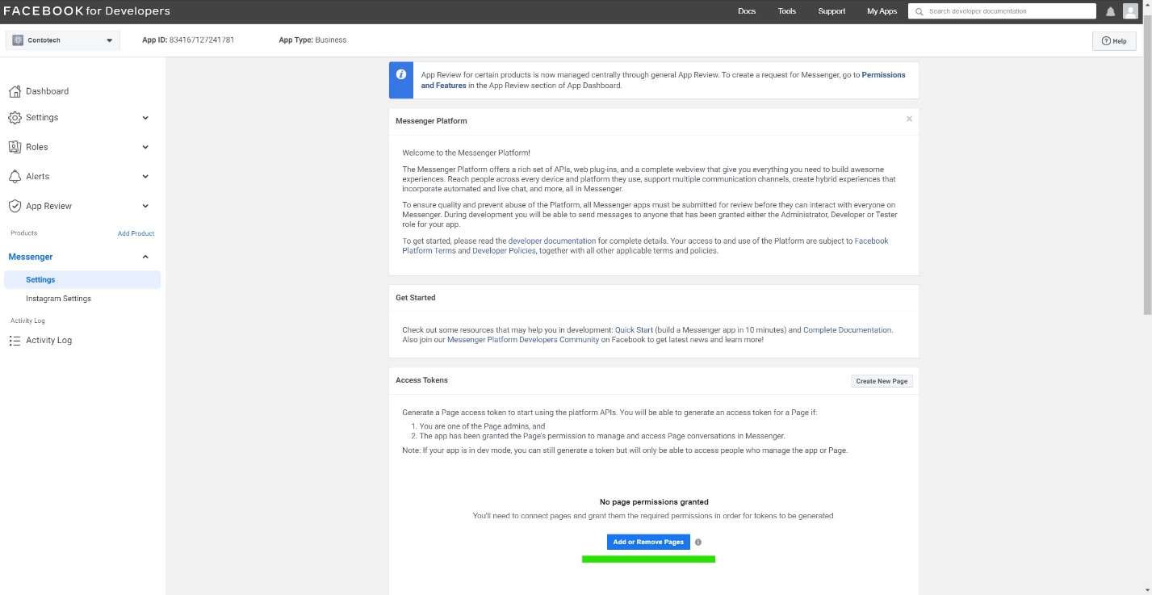
2. Select you newly created page and add into it. Please take not on the line of numbers under your page name, that is the Page ID. Also pay attention to the ‘Generate Token’ button. We will both of it soon in Dynamics 365.  
     
   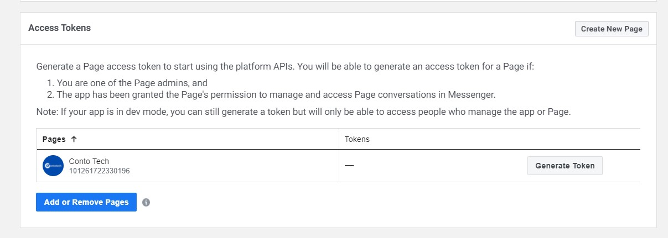
3. Go Back to homepage of developers.facebook.com, and Navigate to Settings 🡪 Basic.  
     
   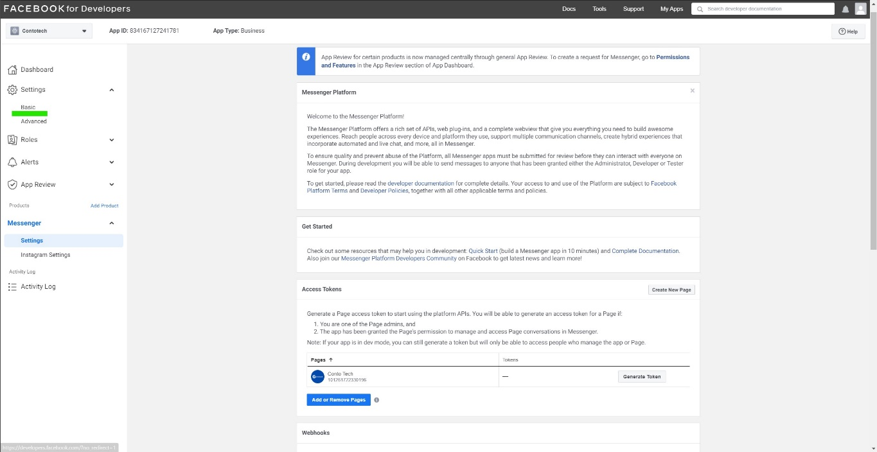
4. You will arrive at this page, and in here you need to take a note on :
   1. App ID
   2. App Secret

We will need this to information in Dynamics 365 soon.

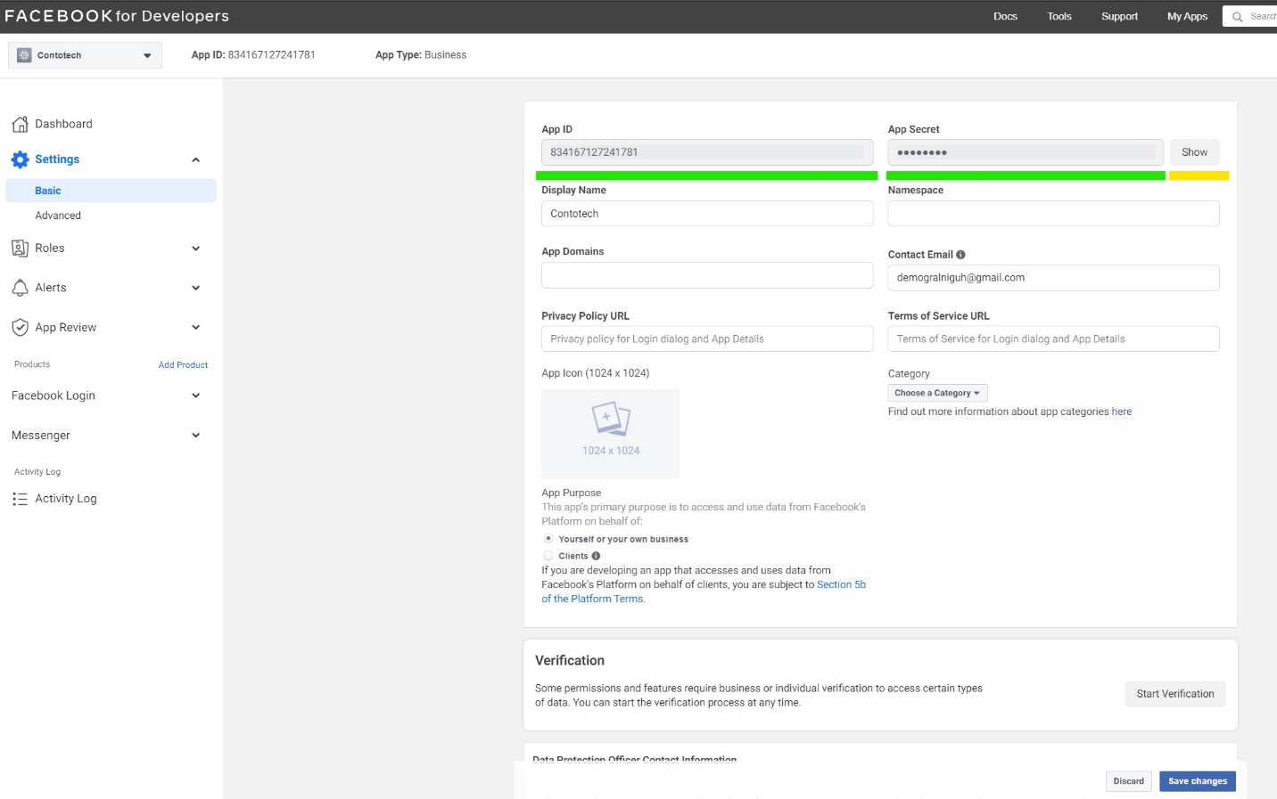

1. Your Facebook messenger app is Ready to be connected to Dynamics 365 Omnichannel.